Key Biotics Terms for Developing Spatial Features

Contents

Stages in the Mapping Process 2

Summary of Spatial Feature Development……………………………………………………………………………………………………………………………………………………………..3

Location Use Class 4

Minimum Mapping Unit (MMU) 4

Conceptual Feature Type 5

Locational Uncertainty Type 6

Representation Accuracy Value 7

Representation Accuracy Key 8

Procedural Buffer 9

Separation Distance 11

Species: Separation by Unsuitable and Suitable Habitats 11

Communities: Separation by Different Community Types 12

Separation Across Mixed Areas 12

Recommended Minimum Separation Distances 12

Factors Determining Separation Distances 13

Separation Distance Analysis & Application 15

# Stages in the Mapping Process

|  |  |  |  |
| --- | --- | --- | --- |
| **SPATIAL FEATURE** | **DESCRIPTION** | **SYSTEM UTILIZED** | **SPATIAL FEATURE RELATIONSHIPS** |
| Observation Feature (*Optional*) | * Created to represent raw observation data * Locational Uncertainty is **not** included in the mapped feature | Kestrel  (or alternative database) |  |
| Source Feature | * Developed from one or more field observations * Locational Uncertainty is always included in the mapped feature, ensuring that the location of the underlying observation(s) is captured within the mapped feature | Biotics |  |
| Element Occurrence | * Developed from one or more Source Features * Consistency is achieved using standard criteria and rules of separation as defined within the EO Specifications record * Developed to define potentially viable conservation units | Biotics |  |

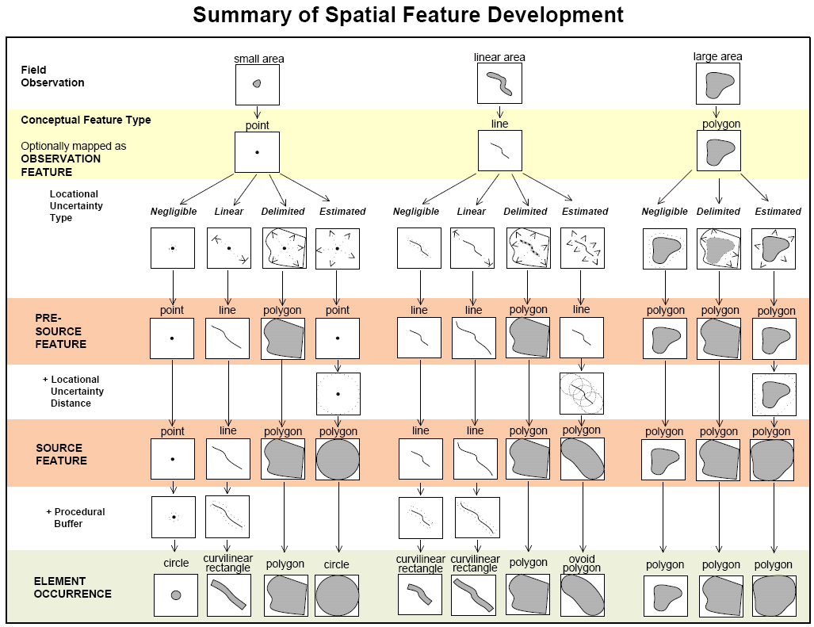

# Location Use Class

Location use classes pertain only to Elements that occupy geographically disjunct locations at different seasons. Classes are not applicable to nonmigratory Elements, and are generally not applicable to terrestrial or freshwater migratory Elements that move between contiguous areas.

For migratory species that utilize geographically and seasonally disjunct (i.e., not contiguous) locations, all EOs (both principal and sub-EOs) should be grouped EOs by their season of occurrence. Because a species may vary in vulnerability during different seasons (e.g., due to more or less aggregation), an EO for a species at a particular season may have greater or lesser conservation value than EOs for the same species at another season. These potential differences in seasonal conservation value between disjunct locations are indicated through the use of LOCATION USE CLASSES (e.g., “Breeding”, “Nonbreeding”, and “Migratory stopover”), thus helping to guide conservation planning. Grouping Source Features of a single Location Use Class within an EO allows identification and conservation of EOs from each vulnerable class, which is vital to the conservation of such species.

Location Use Class is defined within the [EO Specifications](http://help.natureserve.org/biotics/Content/Record_Management/Element_Files/EO_Specifications/SPECS_Introduction_to_EO_Specifications.htm) record for the global element or Element Group to which the global element is assigned. If EO Specs are defined for both the Element and Element Group, the EO Specs of the element takes precedence. If no EO Specs (Element or Element Group) are related to the global element and the element is a subspecies, population, or variety, then the LUC will default to the value defined for the parent species. If no EO Specs are defined, all LUC values are allowed and therefore the default value is **Undetermined**.

# Minimum Mapping Unit (MMU)

Size of the smallest feature that can be delineated with boundaries on a map. The MMU differs by map scale as follows:

|  |  |  |
| --- | --- | --- |
| **Map Scale** | **Diameter of** MinimumMappingUnit | |
| meters | feet (approx.) |
| **18,056** (default) | **9** (default) | **29.5** |
| 36,112 | 18 | 59 |
| 72,224 | 36 | 118.1 |

The minimum mapping unit is used in consideration for determining both the [**Conceptual Feature Type**](http://help.natureserve.org/biotics/Content/Record_Management/Source_Feature/SF_Conceptual_Feature_Type.htm) and [**Locational Uncertainty Type**](http://help.natureserve.org/biotics/Content/Record_Management/Source_Feature/SF_Locational_Uncertainty_Type.htm). Additionally, the minimum mapping unit distance is applied as the [**Procedural Buffer**](http://help.natureserve.org/biotics/Content/Record_Management/Source_Feature/SF_ProceduralBuffer.htm).

# Conceptual Feature Type

Value selected from a drop-down menu that indicates the cartographic feature that would result from mapping the underlying field data, based on the observed feature developed through comparison of the size of the observed area with the [minimum mapping unit](http://help.natureserve.org/biotics/Content/Record_Management/Source_Feature/SF_Minimum_Mapping_Unit.htm) (mmu) for the scale map used.

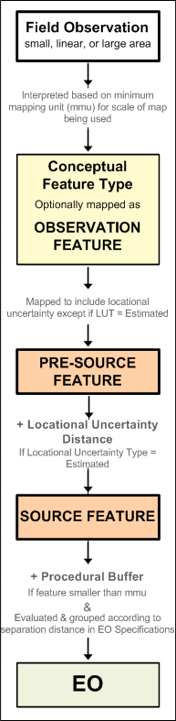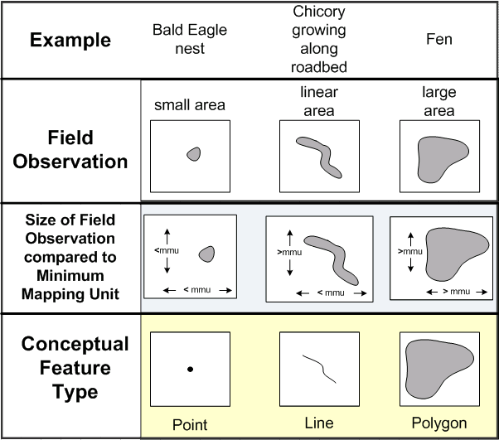

**Point** - The observed feature is a small area (the observed area is less than or equal to the mmu in all directions)

**Line** - The observed feature is a linear area (the observed area is less than or equal to the mmu in one direction, and greater in the other)

**Polygon** - The observed feature is a large area (the observed area is greater than the mmu in all directions)

# Locational Uncertainty Type

Indicates the type of inaccuracy in the mapped location of an observation (i.e., Source Feature) compared with its actual on-the-ground location. This is determined on the basis of the underlying observation data (specifically its size as compared with the [**minimum mapping unit**](http://help.natureserve.org/biotics/Content/Record_Management/Source_Feature/SF_Minimum_Mapping_Unit.htm) (mmu), indicated as the [**Conceptual Feature** Type](http://help.natureserve.org/biotics/Content/Record_Management/Source_Feature/SF_Conceptual_Feature_Type_def.htm)), and the amount and direction of the variability between the recorded and actual locations.

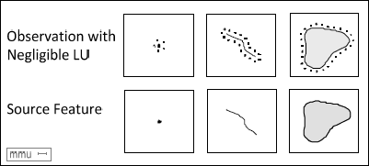**Negligible** - locational variability that is less than or equal to half the [**minimum mapping unit**](http://help.natureserve.org/biotics/Content/Record_Management/Source_Feature/SF_Minimum_Mapping_Unit.htm) (mmu) in any dimension. Source Features with negligible uncertainty are based on a comprehensive field survey with high quality mapping and a high degree of certainty. For example, on a 1:18,056 scale map with an mmu of 9 meters (diameter), a Source Feature will have negligible uncertainty if the uncertainty is less than 4.5 meters in any dimension.

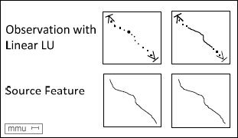

**Linear** - locational variability that is greater than half the [**minimum mapping unit**](http://help.natureserve.org/biotics/Content/Record_Management/Source_Feature/SF_Minimum_Mapping_Unit.htm) (mmu), and varies along an axis (e.g., a path, stream, ridgeline). The true location of an observation with linear uncertainty may be visualized as effectively sliding along a line that delineates the uncertainty.

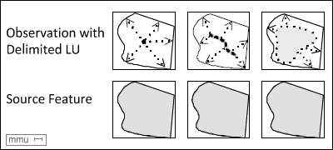**Delimited** - locational variability that is greater than half the [**minimum mapping unit**](http://help.natureserve.org/biotics/Content/Record_Management/Source_Feature/SF_Minimum_Mapping_Unit.htm) (mmu), and varies in more than one dimension. The true location of an observation can be visualized as floating within an area with a boundary that can be specifically delimited. Boundaries can be defined using roads, bodies of water, etc.

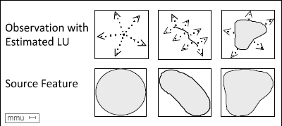**Estimated** - locational variability that is greater than half the [**minimum mapping unit**](http://help.natureserve.org/biotics/Content/Record_Management/Source_Feature/SF_Minimum_Mapping_Unit.htm) (mmu), and varies in more than one dimension. However, a boundary cannot be specifically delimited based on the observation information, i.e., the actual extent is unknown. The true location of the observation can be visualized as floating within an area for which boundaries cannot be specifically delimited. Source Features with Estimated uncertainty require that the user specify a [LocationalUncertainty **Distance**](http://help.natureserve.org/biotics/Content/Record_Management/Source_Feature/SF_Locational_Uncertainty_Distance.htm) to be used for buffering the feature to incorporate the locational uncertainty.

# Representation Accuracy Value

Value selected from a drop-down menu that indicates the level of accuracy associated with the Source Feature (SF). Accuracy varies on the basis of the area observed to be occupied by the Element (Field Observation) relative to the area contained within the footprint of the Source Feature. Differences in these two size values indicate that additional area was included within the feature boundary for locational uncertainty. Representation Accuracy (RA) provides a common index for the consistent comparison of these features, thus helping to ensure that aggregated data are correctly analyzed and interpreted.

A graphic summary of the steps and features in the process for developing an [Element Occurrence](http://help.natureserve.org/biotics/Content/Record_Management/Element_Occurrence/EO_EO_Representation.htm) (EO), including the Source Feature and subsequent features is shown below.

Source Features are created from one or more observations of the Element (Observation Features, if these have been created). Source Features are mapped to incorporate additional area to accommodate any locational uncertainty associated with the underlying field observation. The resulting Source Feature is evaluated for Representation Accuracy using the RA Dichotomous Key.

# Representation Accuracy Key

This key was developed to assess RA for individual observations, i.e., Source Features. However, because Element Occurrences are utilized in conservation planning and analyses, an overall RA value is needed for each EO.

* When the EO is comprised of a single Source Feature, the RA value for the EO would equal the RA assigned to the underlying Source Feature;
* When the EO is comprised of more than one Source Feature, the RA of the EO would be developed using the RA values assigned to each of its component Source Features. In this case, a comment should be entered in the RA Comments field of the EO record describing how the overall RA value was derived.

When the RA values assigned to individual Source Features that comprise a single EO differ significantly (e.g., **High** RA versus **Low**), as would be the case when a historical observation with a large amount of associated locational uncertainty is combined with more recent observations with much less associated uncertainty, consider treating the historical observation as a separate principal EO. In such cases, use the Separation Comments field to explain the rationale for creating separate principal EOs from observations that have been grouped into a single EO according to the EO specifications for the Element.

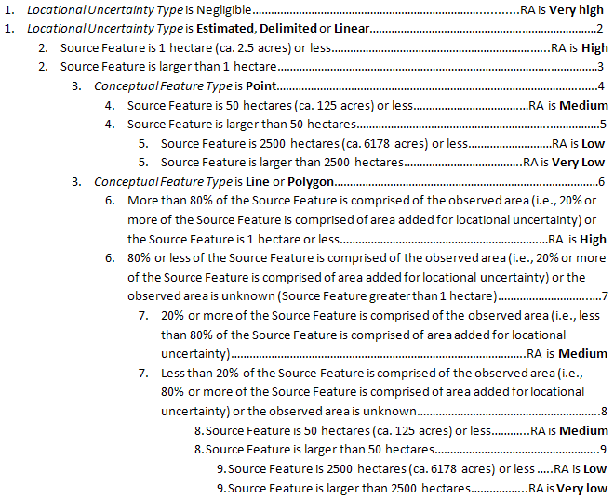

# Procedural Buffer

The primary purpose of procedural buffer is to serve as a visual aid, ensuring that the features are visible at a target scale (see [minimum mapping unit](http://help.natureserve.org/biotics/Content/Record_Management/Source_Feature/SF_Minimum_Mapping_Unit.htm)).

The Procedural Buffer is applied to Source Features with:

* [Conceptual Feature Type](http://help.natureserve.org/biotics/Content/Record_Management/Source_Feature/SF_Conceptual_Feature_Type.htm) of **Point** with Locational Uncertainty Type of [Negligible](http://help.natureserve.org/biotics/Content/Record_Management/Source_Feature/SF_Negligible_Locational_Uncertainty.htm) or [Linear](http://help.natureserve.org/biotics/Content/Record_Management/Source_Feature/SF_Linear_Locational_Uncertainty.htm).
* [Conceptual Feature Type](http://help.natureserve.org/biotics/Content/Record_Management/Source_Feature/SF_Conceptual_Feature_Type.htm) of **Line** with Locational Uncertainty Type of [Negligible](http://help.natureserve.org/biotics/Content/Record_Management/Source_Feature/SF_Negligible_Locational_Uncertainty.htm) or [Linear](http://help.natureserve.org/biotics/Content/Record_Management/Source_Feature/SF_Linear_Locational_Uncertainty.htm).

These cases are defined within the **D_CONC_FEAT_LOC_UNCERT** table, along with the buffer distance used. These are the only situations in which the final Source Feature shape is either a point or a line. Consequently, when processing the Source Feature geometry to include within an EO, the point/line is buffered by half the minimum mapping unit (mmu) distance, so that the diameter is equal to the minimum mapping unit (mmu) distance. Although this procedural buffer is visualized with the SF, it is not actually included in the Source Feature itself, as it does not represent spatial uncertainty. This is done by adding the buffer to the projected layer (WGS), which is strictly used for display, rather than the layer in the program's native projection, which is available for download and provided within the backups.

**NOTE**: Any Source Feature which is smaller than the minimum mapping unit will have a Procedural Feature added strictly for the purposes of visualization on a map of the target scale (see [minimum mapping unit](http://help.natureserve.org/biotics/Content/Record_Management/Source_Feature/SF_Minimum_Mapping_Unit.htm)). In this case, the Procedural Feature is not actually included in the SF (or the EO which it comprises) as the Procedural Feature does not represent spatial uncertainty. This is done by adding the buffer to the projected layer (WGS), which is strictly used for display, rather than the layer in the program's native projection, which is available for download and provided within the backups.

This concept can be seen within the [Summary for Spatial Feature Development](http://help.natureserve.org/biotics/Content/Methodology/SpatialFeatureDevelopmentSummary.pdf).

# Source Feature

A Source Feature is the mapped representation of one or more observations, including [Locational Uncertainty](http://help.natureserve.org/biotics/Content/Record_Management/Source_Feature/SF_Locational_Uncertainty_Type_def.htm) to ensure that the actual on-the-ground location of the underlying observation(s) is captured within the Source Feature.

Creation of a Source Feature requires an interpretive process. The likely location and extent of an observation is determined through consideration of the amount and direction of any variability between the recorded and actual locations of the observation data. The Source Feature is delineated to encompass [Locational Uncertainty](http://help.natureserve.org/biotics/Content/Record_Management/Source_Feature/SF_Locational_Uncertainty_Type_def.htm).

A Source Feature can be a point, line, or polygon. The type of Source Feature developed depends on both the preceding [Conceptual Feature Type](http://help.natureserve.org/biotics/Content/Record_Management/Source_Feature/SF_Conceptual_Feature_Type_def.htm) and the [Locational Uncertainty Type](http://help.natureserve.org/biotics/Content/Record_Management/Source_Feature/SF_Locational_Uncertainty_Type.htm) associated with the feature.

A Source Feature contains a mapped shape of the location as well as data, including repeated visits to that location. Source Features are the components from which [**Element Occurrences**](http://help.natureserve.org/biotics/Content/Record_Management/Element_Occurrence/EO_EO_Representation.htm) (EOs) are developed; however Source Features can also be retained in the database [**independently**](http://help.natureserve.org/biotics/Content/Record_Management/Source_Feature/SF_Independent_Source_Feature.htm) (i.e., without being linked to an EO Rep) to represent discrete observations.

# Element Occurrence

The Element Occurrence (EO) file contains information on the occurrence of priority [Elements](http://help.natureserve.org/biotics/Content/Record_Management/Element_Files/Element_Tracking/ETRACK_Element.htm) in a Natural Heritage Program/Conservation Data Centre inventory. Each record in the file represents a different EO, which is defined as a specific example of an Element at a geographic location characterized by a habitat capable of sustaining or contributing to the survival of the species, or by a landscape that supports the ecological integrity of the community.

An EO is described and ranked, and information on the location, protection, and ownership of the EO are recorded, as well as references to research and documentation on the occurrence. The boundaries of an EO are defined on the basis of one or more observations of the Element (i.e., [Source Features](http://help.natureserve.org/biotics/Content/Record_Management/Source_Feature/SF_Source_Feature_def.htm)) at a particular location, which may be associated with one or more [Managed Area](http://help.natureserve.org/biotics/Content/Record_Management/Managed_Area/MA_Managed_Area.htm)(s) and/or [Conservation Site](http://help.natureserve.org/biotics/Content/Record_Management/Site/SITE_Site.htm)(s).

EOs are the practical building blocks of the Heritage inventory, used extensively in environmental review, Conservation Site selection and design, and conservation planning. EOs are the basis for protection and stewardship activities for the preservation of Elements of natural diversity.

# Separation Distance

In addition to [barriers](http://help.natureserve.org/biotics/Content/Record_Management/Element_Files/EO_Specifications/SPECS_Separation_Barriers.htm) that totally, or almost completely, prevent movement and/or dispersal, distances of intervening area that restrict movement may also separate EOs. These distances are used to delineate the population units between which gene flow is significantly reduced. For comparison, IUCN (1996) characterizes reduced gene flow between units as “typically one successful migrant individual or gamete per year or less”. For most species, data from gene flow studies does not exist; thus, decisions on separation distances should be made on the basis of best information available. Also, consideration of gene flow is not applicable to Elements that disperse widely (e.g., birds, wind dispersed plants or insects), Elements having very long generation times (e.g., giant tortoises, plants characterized by long-term seed banking or dormancy, persisting clones), or Elements that are dependent on rare but recurrent phenomena for dispersal (e.g., floods, major storms).

A separation distance is the amount of intervening area that determines whether Source Features of an Element should be grouped as part of the same (complex) Element Occurrence (EO), or should be considered as discrete Element Occurrences.

Separation distances will be provided in the EO specifications for the Element. For species, distances are provided for intervening areas of unsuitable habitat, and for suitable habitat that is not known to be occupied. For communities, distances are provided for intervening areas of different natural/semi-natural communities, and cultural vegetation.

The intent of assigning values for separation distances is to achieve consistency in the manner in which EOs are defined and mapped. The degree of restriction to movement and/or to dispersal of the Element resulting from the intervening area determines the distance(s) required to separate one EO from another. Thus, areas that are highly restrictive to the Element’s movement or dispersal require smaller distances for separating EOs than areas less prohibitive to movement or dispersal.

Several factors may be used to set separation distance(s) for EOs. The factors used to determine separation distances for EOs should be cited as justification in the EO specifications.

In the absence of EO specifications providing separation distances, [minimum values](http://help.natureserve.org/biotics/Content/Record_Management/Element_Files/EO_Specifications/SPECS_Recommended_Minimum_Separation_Distances.htm) have been recommended.

* [Species: Separation by Unsuitable and Suitable Habitats](http://help.natureserve.org/biotics/Content/Record_Management/Element_Files/EO_Specifications/SPECS_Separation_Distance_def.htm#Species)
* [Community: Separation by Different Community Types](http://help.natureserve.org/biotics/Content/Record_Management/Element_Files/EO_Specifications/SPECS_Separation_Distance_def.htm#Communities)
* [Separation Across Mixed Areas](http://help.natureserve.org/biotics/Content/Record_Management/Element_Files/EO_Specifications/SPECS_Separation_Distance_def.htm#Mixed)
* [Separation Distance Analysis & Application](http://help.natureserve.org/biotics/Content/Record_Management/Element_Files/EO_Specifications/SPECS_Separation_Distance_def.htm#top)
* [Recommended Minimum Separation Distances](http://help.natureserve.org/biotics/Content/Record_Management/Element_Files/EO_Specifications/SPECS_Separation_Distance_def.htm#RecommendedMinimum)
* [Factors Determining Separation Distances:](http://help.natureserve.org/biotics/Content/Record_Management/Element_Files/EO_Specifications/SPECS_Separation_Distance_def.htm#Factors)
* [Dispersal Distance](http://help.natureserve.org/biotics/Content/Record_Management/Element_Files/EO_Specifications/SPECS_Separation_Distance_def.htm#DispersalDistance)
* [Home Range](http://help.natureserve.org/biotics/Content/Record_Management/Element_Files/EO_Specifications/SPECS_Separation_Distance_def.htm#HomeRange)
* [Spatial Patterns of Occurrence](http://help.natureserve.org/biotics/Content/Record_Management/Element_Files/EO_Specifications/SPECS_Separation_Distance_def.htm#SpatialPatterns)
* [Temporal Patterns of Occurrence](http://help.natureserve.org/biotics/Content/Record_Management/Element_Files/EO_Specifications/SPECS_Separation_Distance_def.htm#TemporalPatterns)
* [Comparability with Similar Function Groups](http://help.natureserve.org/biotics/Content/Record_Management/Element_Files/EO_Specifications/SPECS_Separation_Distance_def.htm#Comparability)

## Species: Separation by Unsuitable and Suitable Habitats

When applicable, two separation distances should be specified for species Elements: one across unsuitable habitat, and another across apparently suitable habitat that is not known to be occupied (regardless of whether surveyed). The use of these distances in defining EOs is designed to reflect hypothesized differences in gene flow across suitable vs. unsuitable habitats. However, for some species Elements, there will likely be no significant differences in gene flow across the different habitats. In these cases, only one separation distance need be specified. To promote consistency in the application of separation distances, they should be measured along the shortest route of expected travel of the Element between the edges of the known or minimally estimated occupied habitat, although this may not be a straight line (see Section 7, EO Spatial Representation).

For all species Elements, the distance of unsuitable habitat needed to separate EOs is always less than or equal to the distance of apparently suitable but unoccupied habitat needed to separate EOs. Because the unsuitable habitat cannot support the Element, a specified distance of this habitat can be more prohibitive to dispersal and residence by the Element than the same distance of apparently suitable habitat. Thus, separation by unsuitable habitat is presumed to be more definitive. Further survey work is unlikely to result in the discovery that the separation was inaccurate. It is also unlikely that unsuitable habitat will become occupied over time, and therefore, the separation between two EOs will presumably remain.

## Communities: Separation by Different Community Types

For community Elements, habitat suitability or unsuitability is not applicable. Instead, community EOs may be separated by expanses of different natural or semi-natural community types, or cultural vegetation. Intervening natural and semi natural areas will likely inhibit the expansion or function of community EOs to a lesser degree than intervening cultural vegetation. In a like manner, intervening natural and semi-natural areas with similar kinds of habitat characteristics will inhibit expansion or function of a community less than those with very different kinds of characteristics. For example, bogs separated by intervening areas of upland jack pine on bedrock are more definitively identified as distinct EOs than bogs separated by areas of black spruce swamp.

## Separation Across Mixed Areas

Frequently, the area located between populations or patches may consist of a mixture of apparently suitable and unsuitable habitat, or a mixture of other natural or semi natural community types and/or cultural vegetation. When applying EO specifications, if no mixed habitat guidance is provided, the separation distances to be applied should bec onceptually based on the relative amounts of apparently suitable and unsuitable habitat.

## Recommended Minimum Separation Distances

Minimum values for separation distances have been recommended to ensure that EOs are not separated by unreasonably small distances, which would lead to the identification of unnecessarily fragmented populations as potential targets for conservation planning or action. For species Elements, minimum separation distances are generally 1 km or greater for both unsuitable habitat, and for apparently suitable habitat that is not known to be occupied. For communities, the minimum separation distance delineated for intervening areas of different natural or semi-natural communities is 1 km or greater, and a distance of at least 0.5 km for interjacent areas of cultural vegetation. Table 4.1 summarizes the recommended minimum separation distances for species and community EOs.

|  |  |  |
| --- | --- | --- |
| **Type of** Separation | **Species EOs** | **Community EOs** |
| barrier | qualitatively defined | qualitatively defined |
| unsuitable habitat | ≥ 1 km | N/A |
| apparently suitable habitat not known to be occupied | ≥ 1 km | N/A |
| cultural vegetation | N/A | ≥ 0.5 km |
| different natural or semi-natural communities | N/A | ≥ 1 km |

Although some Elements may occur as truly separate populations at scales of separation less than 1 km, the practical value (for conservation planning and action) of delineating finer-scale EOs is often questionable. Nevertheless, a few Elements may require separation distances that are less than the established minimum; in such cases, these distances should be justified in the EO specifications.

## Factors Determining Separation Distances

Several factors that may be considered when determining separation distances to be written in the EO specifications for a given Element:

### Dispersal Distance

For species Elements, dispersal distance is the distance that individuals or propagules (e.g., pollen, seeds, spores, larvae) travel from an existing location to a new location. Success of dispersal depends on whether suitable habitat for establishment is reached within that distance. Typical dispersal distance for an Element is rarely known and may be extremely variable. However, since dispersal allows genetic connectivity between otherwise apparently distinct populations, separation distances between EOs should be greater than the distance of routine dispersal events.

For many Elements, a small percentage of individuals or propagules may disperse great distances. While potentially significant for establishing new populations and for reducing genetic differentiation of populations, these rare, long-distance dispersal events should not be factored into separation distances. For migratory species, dispersal distance is not a useful concept for determining separation between populations since these Elements may typically disperse over enormous distances. Considering dispersal distances in determining separation distances for such Elements may lead to impracticably large EOs.

### Home Range

In the absence of information about dispersal distance for animals, home range size may be a useful surrogate for that knowledge based on a presumed relationship between the two. For some animals, home range is the average area occupied, utilized, and/or defended by an individual, either during its lifetime or for a given breeding season. The true extent of home range is often not well known, and may vary from year to year, and between different habitats. Generally, separation distances should be at least three times the average home range for the Element (i.e., based on the length of the largest axis). In cases where the area of a home range is not known but information is available on movement (excluding dispersal and migration), use three times the distance of that movement. This distance would ensure that EOs that are, in fact, distinct remain separate despite fluctuating home range boundaries through defining adequate space between them to allow for such fluctuations.

### Spatial Patterns of Occurrence

The relative degree of spatial patchiness of an EO is an important factor when determining separation distances for EO specifications. Spatial patterns can be measured by the size of the EO, separation between EOs, and/or the surrounding context of the EO (e.g., the degree of unsuitability of the surrounding landscape).

For matrix communities, it may be difficult to develop separation distance guidelines due to their extensive and complex spatial patterns. Large readily recognizable stands that qualify as distinct EOs according to the separation distance guidelines may, nonetheless, be connected by smaller less apparent stands located within the prescribed separation distance. When such cases are found in natural or semi natural landscapes, the smaller and larger stands may be grouped into one principal EO, with sub EOs used to define the individual stands. However, in more altered landscapes, the intervening small stands are less likely to create a meaningful connection between the large stands; thus, large stands would be maintained as separate principal EOs.

### Temporal Patterns of Occurrence

Changes in spatial patterns over time, including many successional phenomena, may also be considered when writing EO specifications. In general, separation distance guidelines will depend on the rate of change.

If spatial changes occur relatively frequently (e.g., within a practical time frame of 25 years), then separation distance guidelines should be adjusted to incorporate the relatively dynamic temporal/spatial nature of an occurrence. In other words, because a principal EO with dynamic characteristics represents all potential varying locations of that population or community over a given time period, it encompasses an area larger than what is actually occupied at the time of survey. Thus, greater separation distances should be specified to ensure that a shifting population or patch is not recorded as multiple separate occurrences over time.

On the other hand, if spatial changes occur relatively infrequently (e.g., the population or community remains at a particular location for longer than 25 years), then for all practical purposes, separation distance guidelines should reflect the relatively stable nature of the occurrence. In other words, temporal factors should be considered largely irrelevant, and separation distance guidelines should be based on current factors only.

Temporal patterns of occurrence may be an important consideration for many species (e.g., birds that are dependent on grassland communities; plants characterized by seed banking that may only be apparent for discontinuous periods of time). Temporal patterns of occurrence may also be an important consideration for very dynamic communities (e.g., meadow and marsh communities that move up and down streams in relation to beaver dams). In each of these cases, occurrences may not appear to persist locally if considered at one time only, but do persist in the larger landscape over a longer time frame.

### Comparability with Similar Functional Groups

Similarity in components of species biology or community processes (e.g., a - d above) between Elements may be an important consideration in developing EO specifications. This functional similarity is often found in groups that are related through taxonomy, shared ecological factors, or some combination of the two (e.g., “alliance” for communities, “genus” for species, ecological groups within an alliance). However, groups may be functionally related without having any taxonomic relation (e.g., conifer and mixed matrix communities occurring in the same pattern in a boreal ecoregion, riffle dwelling mussel species occurring in similar patterns of abundance). Functionally similar Elements should have comparable separation distances; it would normally not make sense to specify separation distances for functionally similar Elements that differ by an order of magnitude.

These factors to be considered in determining separation distances may be dependent on other components (e.g., landscape may affect dispersal distance, population density may influence home range size, and sex may determine average movement distance). Although multiple factors may influence the decision on separation distances specified, the most significant factor(s) should be provided as justification in the EO specifications.

## Separation Distance Analysis & Application

