NatureServe Model Outputs Review Tool (MORT)
Version 1 – Users Guide

Note: Please download the document in your desktop MS Word app for dynamic visualizations (GIFs) to be displayed correctly.

Background
NatureServe’s Model Outputs Review Tool (MORT) is an interactive web-based application to facilitate collaborative review of Species Habitat Models (SHMs) and collection of feedback to aid modelers in improving outputs. Our goal has been to provide a simple interface that enables users to view the modeled extent of species habitat, register general comments, and provide feedback on where model results are and are not consistent with expert knowledge. Our primary focus is to support the collection of actionable information to support model refinement – we want to know whether habitat maps are consistent with general understanding of the distribution of habitat for a given species and to identify steps that will lead, often in an iterative way, to highly vetted, refined habitat maps.
Model predictions in the review tool are shown at resolutions of 30m to 330m grid cells (or medium-resolution National Hydrography Database stream segments for aquatic species), depending on the size of the model extent. Regardless of the specific resolution you are viewing, please keep in mind during your review that model outputs will frequently be scaled up for final products and thus we are most interested in whether the model generally shows habitat where you expect the species may occur, not whether a particular pixel or small group of pixels is correct or not.
This document provides step by step guidance on how to access and use the tool. The information you provide will be invaluable for improving models and in some cases quantifying uncertainty in the underlying data.
If you are interested in reviewing a model for which you do not have access, please contact Gio Rapacciuolo (Giovanni_Rapacciuolo@natureserve.org) or Hannah Hyatt (data_science@natureserve.org)

Setup
Once you have signed up to review a species, you will receive an email from noreply@shinyapps.io that invites you to create an account to access MORT. Please click on the link that is provided in the email to sign up for an account to access MORT. Once you click on the link you will be taken to a page that shows the following message:
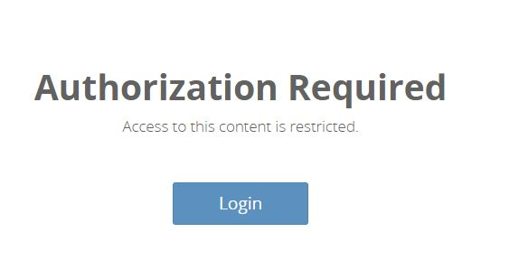
Click on the “Login” button and a pop-up window will appear prompting you to either sign in with an existing account or sign up to create a new one. Please choose the latter and create an account using the same email you received the invite in. Once this is done, you will be able to access MORT by clicking on the link below.
https://natureserve.shinyapps.io/model-outputs-review-tool/
If you have trouble finding the shinyapps.io email, creating an account, or accessing MORT please contact Gio Rapacciuolo (Giovanni_Rapacciuolo@natureserve.org) or Hannah Hyatt (data_science@natureserve.org )
Once you have opened MORT, Select the species you wish to review from the dropdown menu found at the top of the window.
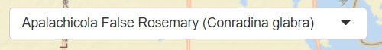
Species Name
Using the Tool: Tips and Tricks
There are a few important things to note about using the latest MORT which is built using Shiny architecture that are different from our previous version of MORT which was on AGOL architecture. Please read through the below before beginning your review:
- MORT will time out if you leave your screen, or tab that the tool is open on, idle for an extended period. We recommend that you set aside a period of time to complete your review from start to finish so that you don’t lose any comments or work.
- If you are reviewing a wide-ranging species or an aquatic species it is likely that the model will take some time to load in MORT, especially if there are many threshold changes being applied. Please keep this in mind and be patient as you provide your review.
  - Another important thing to point out about aquatic species: stream segments were simplified to reduce model loading times; this means that some of the streams may not appear as expected or match the basemap perfectly.

Using the Tool: Features and Functions
The primary components of the tool are found on the left side of the tool interface. Here is what they do.
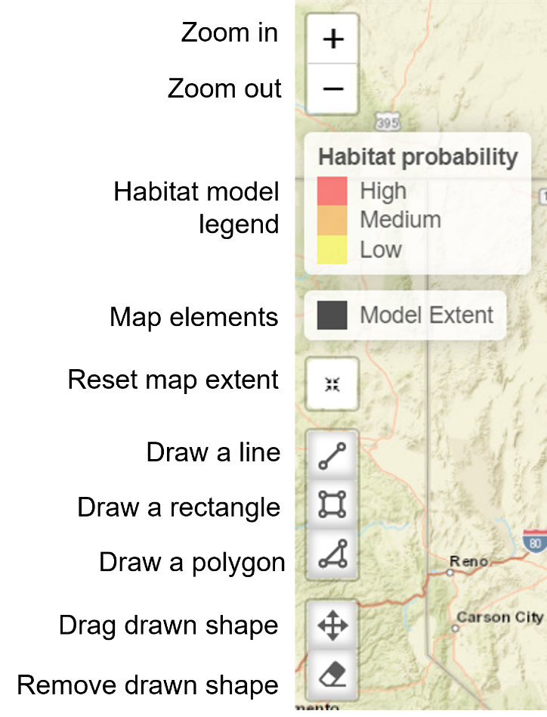
On the bottom left, you will find the option to change the base map and turn on and off various data layers in the app.
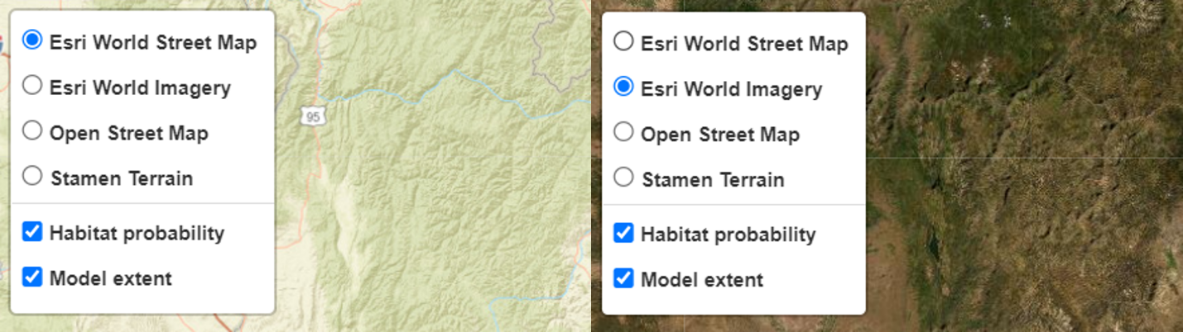
At the very top of the app interface, you will find a “View model details” button. If you click this, a summary PDF for the model will be opened in a new tab. This PDF summarizes the model inputs and modeling methods, validation statistics from modeling runs, and the model’s confidence and recommended uses.
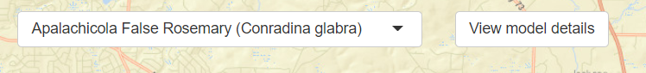
Species Name
A second tab at the top of the app presents the Model Review History if the model has been reviewed before. This page details comments other reviewers may have made on previous versions of the model and outlines how the model may have been revised as a result of those comments.
Step 1: Adjust Habitat Probability Threshold
First, we ask reviewers for feedback on geographical predictions of habitat probability generated by the model. The three categories (low habitat probability in yellow, medium habitat probability in orange, high habitat probability in red) are defined by three threshold values. On the right side of the window, a panel lists the three thresholds and enables you to update those thresholds to reveal more or less of the predicted habitat probability area or change the relative proportion of each habitat category. To update habitat probability thresholds, slide the marker on the bar for the corresponding threshold value. To suggest that thresholds be updated to reflect your understanding of the habitat distribution for this species, leave the thresholds at the updated value and those suggested values will be submitted to us when you finalize your review. You can also provide additional comments on why you propose different thresholds than those predicted by the model in the corresponding comment boxes. Once you are happy with your threshold settings and comments, click the “Next Step” button on the bottom right of the panel to save your work and move on to the next reviewing step.
If you want to see the original thresholds predicted by the model, click the reset button on the right side of the panel. Appendix 2 of the model summary PDF defines each threshold in further details.
Species Name
If permissions are available, you may see the species occurrence data that was used as a model input on the map. In this situation, if you hover your cursor over the data points and click on them, you can find out general information about the occurrences. You can turn these data on and off with the interactive legend on the bottom left of the window.
Step 2: Provide Map Comments
Next, we ask reviewers to provide more detailed comments on specific areas of the map, if any. This is where reviewers can indicate whether they would expect geographical areas to be included or excluded from areas of predicted habitat. Comments can be applied to areas both inside and outside the model extent: the geographical area over which we ask the model to search for potential habitat for the species. The model extent is indicated by a thick transparent grey line. Reviewers can also provide specific feedback on predicted habitat probabilities mapped in this section, by indicating where more or less habitat should be predicted.
To provide comments on specific areas on the map, reviewers can use the drawing tools available on the left of the map. For example, you can draw a rectangle and include your feedback on the drawn area using the pop-up window on the right panel of the map: this includes selecting an action from the dropdown menu at the top and optionally entering a comment in the text box. Clicking “Save” will save and submit your comments, while “Cancel” will delete your comments.
Species Name
Alternatively, you can draw a line and suggest removing all areas above or below it.
Species Name

Once you are satisfied with your feedback in this section, click the Next Step button on the bottom right of the map.
Step 3: Review Environmental Predictors
Next, we ask reviewers to provide feedback on the primary environmental predictors (influential above a set threshold) selected by the model out of all the environmental predictors included in the modeling process to characterize habitat for this species. Here, you can see the list of environmental predictors that the model identified as most influential for this species – variables which best discriminated between areas where the species has versus has not been recorded – ranked based on their importance. Reviewers can provide feedback on these influential variables using the comments box below the graphic. For instance, reviewers may want to highlight whether variables essential to identifying habitat for the species seem to be missing from this list. Once you are satisfied with your feedback, click the Next Step button on the bottom right of the map.
**Important note: the importance of an environmental predictor does not indicate the direction (positive or negative) of relational importance. **
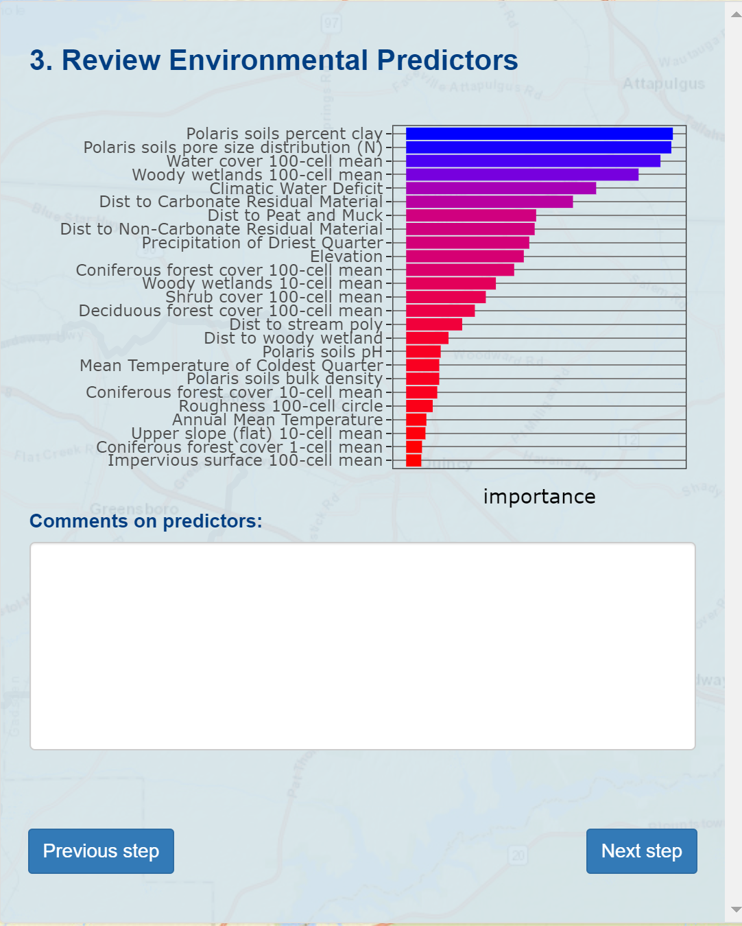
Further details about the environmental predictors can be found in the Species Habitat Model Summary PDF (accessed by clicking “View model detail” button).

Step 4: Rate Model and Submit
Finally, we ask that reviewers provide overall feedback on the model in this section. Overall Feedback consists of 1) a star rating ranging from one to five stars, and 2) written comments justifying the rating given. Both should reflect your view of how well the model captures likely species habitat. Star ratings and comments should apply to the quality of the modeled habitat (yellow, orange and red habitat probability categories on the map), rather than the input species occurrence data (black polygons/circles) or modeling extent (thick grey line).
Reminder: Overall Feedback (i.e. a star rating and associated comments—regardless of how brief) must be provided for every model reviewed. When you have selected a star rating and provided comments, please also remember to click the “Submit” button to ensure that your inputs are captured for use by the modeling team.
Please see Appendix A for additional guidance on how to best populate the star ratings and overall comments. The “model extent” is provided only to provide geographically specific comments that can be used to modify the modeled habitat. Because multiple biologists may provide reviews for a single species, the modeling team will weigh comments from different reviewers in deciding what action, if any, will be taken to modify a given model.
Star Rating | Brief Meaning
ó | Poor representation of habitat. Habitat for this species is unlikely to be successfully mapped using standard SHM approaches given unique species traits.
óó | Significant concerns. A large proportion of the map shows habitat in areas where the species is unlikely to occur or does not predict habitat where the species is known. Revisions are needed before the model is used for any formal application or decision, with the possible exception of guiding inventory.
óóó | Some concerns about model performance in specific areas. The model would benefit from additional refinement, but the general pattern of mapped habitat is consistent with expert expectations.
óóóó | Model generally good. Potential for further improvement through additional iteration but provides a good approximation of likely habitat.
óóóóó | Modeled habitat is a very good representation of likely habitat. Further iteration is unlikely to result in significant improvements based on our current understanding.
The comment field should be used to provide feedback on (1) model performance, (2) confidence of the reviewer (including geographic area of expertise), and (3) recommendations for model revisions or development of an alternative map.
Suggestions on ways to improve the model (additional sources of locality data to train the model, additional environmental predictor layers that might be important for the species, adjusting the threshold used to create the habitat map, etc.) are also of great value.
We encourage the use of standard language in the comments, as it can help us better query the feedback received; please see Table A2 in Appendix A for recommended keywords.
If you provide a 1-star rating for any model, it is important that you provide suggestions on a better way to map habitat for the species (for example, buffering Element Occurrences (EOs) or using some other existing map).
Once you are content with your entire review, please click the “Submit” button at the bottom right of the page. Once your review is successfully completed you will be greeted with the following message. Thank you!
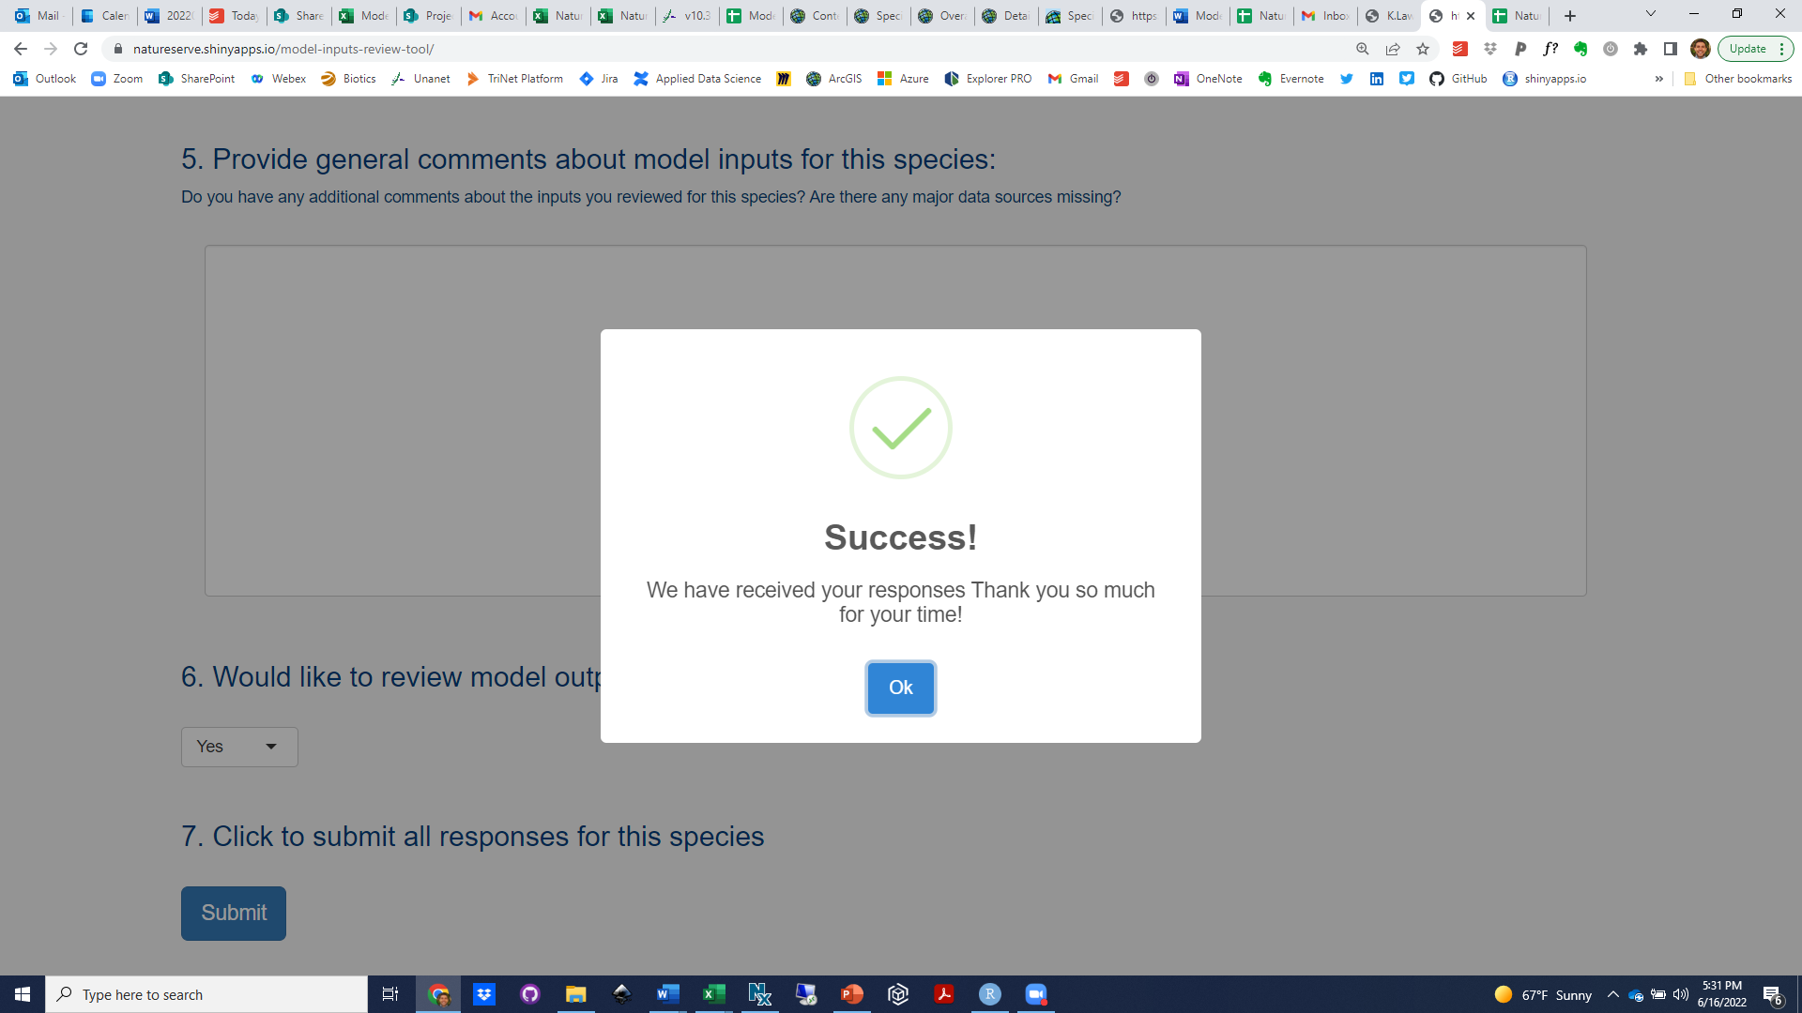

How Your Reviews Will be Used
The modeling team will be able to view comments received from one or multiple reviewers, as well as export tabular information on feedback received. In instances where reviewers have indicated areas that should be removed from the modeled distribution, or added and the model rerun, we can efficiently process those changes to produce a more accurate map. Depending on the level of detail of comments, the modeling team may (1) decide to use the model as is, (2) make targeted changes to model inputs (occurrence data and environment variables) and rerun the model, or (3) consider alternative distribution mapping approaches.
Please note that we may include your comments as part of documentation associated with the final model outputs.

Appendix A: Additional Guidance on Overall Model Ratings
Table A1. A Detailed Guide to Star Ratings

Table A1  Star Ratings |   1-Star | 2-Star |   3-Star | 4-Star | 5-Star
What It Means | The distribution map (yellow, light green, and dark green in review tool) is not at all an accurate representation of where the species is likely to occur. A HSM is unlikely to work for this species. Use a different approach for mapping the distribution of the species. | The distribution map has significant problems; it may be suitable for formal decision support if and only if modeled area within the selected HUCs are added/removed. Even then, the model would benefit from significant further refinement. | You have some concerns about the distribution map that are likely addressed through modifications to the modeling extent (HUCs) and/or the reviewer thinks the model may be a decent representation but does not have the knowledge to note that with high confidence. | You feel the distribution map provides a good approximation of actual species habitat but could likely benefit from additional review and refinement. | you are confident that the distribution map is a good approximation habitat, and that the model is suited at least some formal applications that typically require a high degree of confidence in the map. Choose this option if the map looks good and in your estimation is unlikely to be significantly improved through additional iteration.
Comment Requirements | Suggest an alternative method for mapping the distribution for this species (e.g., use buffered EOs, use a distribution map from another cited source). Provide some indication of the area you reviewed (full range? one state?) and your confidence in your rating. | Indicate what is driving your concerns about the model (too much habitat predicted? not enough? habitat in the wrong places?) and whether adding/removing HUCs will or will not address most of those issues. Suggestions on other ways to improve the model (sources of additional locality data, additional environmental predictors) are welcome. Provide some indication of the area you reviewed (full range? One state?) and your confidence in your rating. | Indicate the sources of concern, or uncertainty, about the model including whether adding/removing the HUCs will or will not address most of those concerns. More specific suggestions on ways to improve the model are also welcome. Provide some indication of the area you reviewed (full range? One state?) and your confidence in your rating. | Indicate any sources of concern or uncertainty (i.e. why you did not give 5 stars). General comments welcome. Provide some indication of the area you reviewed (full range? One state?) and your confidence in your rating. | General comments welcome. Provide some indication of the area you reviewed (full range? One state?) and your confidence in your rating.
Implications for iterative model improvement | The species will not be considered a good candidate for future HSM efforts. An alternative distribution mapping approach will likely be used to represent the distribution of this species. | The model will be further refined prior to the modeling team recommending any formal use. In some cases, the model may be revised using additional training or predictor data. | Depending on input from other experts the model will likely be revised before its use in any formal application or decision support role is recommended. | Depending on input from other experts, the model may be recommended for use in formal applications or decision support *or* further refined. | Depending on input from other experts, the model will most likely be recommended for use in formal applications or decision support, though it is recognized that additional review, iteration, and improvement is often possible.

Table A2. Keywords for Model Comments
The overall comments field in the model review tool is intended as a flexible platform to provide model feedback. While not required, use of standardized keywords provides an efficient means for us to interpret the comments received. Below, we have provided several keywords that we encourage you to use both for the overall comment, and, as applicable, for comments for individual HUCs. The keywords are broken down by category; at a minimum, please provide general commentary on the model prediction and confidence in your review.
Type of Comment | Description | Keywords
Model Prediction | Provide comments on general model performance; how well does the model do at representing likely habitat? | Overpredicts – shows too much area as habitat  Underpredicts – does not show enough area as habitat  Unlikely to be occupied – areas predicted as habitat may in fact be habitat (have suitable environmental conditions) but are unlikely to support the species given other constraints (dispersal limitations, etc). Provide details using the model extent (HUC) comment function.  Missing important areas – the model is good in areas but leaves out some important habitat. Provide details using the model extent (HUC) comment function.  Inconsistent – the model performs well in some places, but not in others. Provide details using the model extent (HUC) comment function. (e.g. “The model prediction is inconsistent: appears pretty accurate in the Northeast, but less so in central PA. See HUC comments for additional details.)
Confidence of Reviewer | Provide comments on your confidence in your review, including the geographic scope of your knowledge. | Low Confidence – the reviewer has limited knowledge of the species and/or it’s habitat  Medium Confidence – the reviewer has decent knowledge of the species and has medium confidence in his review  High – the reviewer knows the species well and is confident in her review  Geographically limited expertise – the reviewer is only able to provide good feedback for part of the species range. Please specify by state, ecoregion, or other standard geographic region.  Additional Review – use this term to recommend other expert(s) we may want to contact for review
Model Revision Recommendations | For 2, 3, or 4 star ratings, provide comments on ways you think the models might be improved. Comments need not be limited to the keywords suggested. | Locality data – use this term if providing commentary on additional sources of locality data that could be used to train the model (e.g. “You might want to check with the XXX botanical garden for additional locality data”)  Predictor data – use this term is providing commentary on environmental data that could be used to improve the model (e.g. “Model is likely adversely impacted due to a lack of predictor data delineating floodplains”)  Model extent – use this term to indicate that the model could be improved by adjusting geography for which the model was run (e.g. “Suggested model revision: This would be better if you clipped the model extent to exclude anything west of the Coastal Plain – see the HUC comments”)  Adjust the threshold – use this term to suggest that the threshold used to create the predicted habitat map from the probability model should be reconsidered to yield more or less mapped habitat (e.g., “The model underpredicts; can you adjust the threshold to show more habitat?”)

Appendix B: Frequently Asked Questions
Am I supposed to be commenting on the predicted habitat (yellow, orange, and red) or modeling extent (black outline)?
While we are most interested in feedback on the predicted habitat, comments on the modeling extent can be an efficient and valuable basis for important model refinement. Removing areas from the mapped distribution provides an easy means of removing egregious cases of erroneous mapping. Adjusting the modeling area to include additional areas allows for habitat to be predicted in those areas (but does not guarantee habitat will be mapped there, as that will depend on whether environmental conditions in the area are consistent with those predicted to be habitat).
How were these maps made?
See the model-specific metadata documentation for how a predicted habitat map was developed. To access the metadata, click on the “View model details” button at the top of the model review tool. The maps displayed in the review tool were created by applying a threshold to the continuous (0 to 1) probability surface generated by the model. Thresholds are defined in the metadata.
Who is involved in the modeling work?
This will depend on the specific project or effort within which modeling efforts are taking place. In some cases, models are being developed through collaboration of multiple programs within the NatureServe network. Models are developed using data and expertise from the entire NatureServe network and beyond.
What locality data was used to build these models?
Data used to build the models typically includes all records in NatureServe’s multijurisdictional data set at the time of modeling, including observation data sets from select states. Additional occurrence records may be obtained from the USGS’s BISON (Biodiversity Information Serving Our Nation) system and well-documented sources. Data are typically filtered so as to include only high confidence occurrences from no earlier than 1980, unless historical data are considered to be informative, or limited data are available.
What environmental predictor data was used to build the models?
NatureServe and the NatureServe network collaborated with Esri to build a national-scale library of over 200 predictor layers representing a wide variety of geographically explicit biophysical information. For aquatic models, environmental predictor variables mapped to the medium-resolution NHD were primarily derived from StreamCat. For some geographies, additional regional predictor data sets were also used for regional endemics. Predictor data of greatest importance for any particular model is documented in the model metadata. Further details on this national environmental predictor library are available from NatureServe.
The model I am reviewing – especially the metadata – looks very different from the information available for other species. Why is this?
In some cases, it becomes apparent that, standard habitat suitability modeling techniques are not the best approach to deriving accurate distribution data for a given species. For example, some species might be associated with environmental conditions that are not well represented in available datasets (for example, karst species) or not have adequate locality data to support an inductive modeling approach. In these cases, deductive or other approaches may be used to develop distribution models. Maps developed using these alternative approaches may also be made available for review via the model review tool. Details on how they were developed will be provided in the metadata.
How should “Predicted Habitat” for bird species be interpreted? Is this for breeding habitat only, or does it also encompass migratory and wintering habitats?
“Predicted Habitat” results for birds should be interpreted as the breeding habitat unless otherwise noted. Non-migratory species were modeled using all available observation data. Under our current modeling conventions, migratory species are modeled using data filtered by 'safe dates' for breeding and for wintering. Also note that models do not extend beyond the continental US.
I don’t have the knowledge to comment on how well the model does across the entire species range. How do I indicate what area I reviewed?
Please capture this in the last comment box of the overall feedback panel, referencing for which states or other geographies your review is relevant for.
What if I only know a little about a species, and am not confident in my ability to do this review well?
Please complete the review to the best of your ability and indicate in the comments your confidence in your knowledge.
How do I get somebody else with more knowledge than me access to review the species?
If you have recommendations for additional reviewers, please share that information with Gio Rapacciuolo (Giovanni_Rapacciuolo@natureserve.org) or Hannah Hyatt (data_science@natureserve.org) and capture it in the model review comments.
How are you going to use all the information I provide?
Review information provided by experts will contribute to strategic decisions about what steps can best be applied to improve models.
In cases where areas have been identified for removal from the modeling extent, we will run scripts to clip the models as specified. When it is indicated that an area should be added to the modeling extent, we will do so, and rerun the model, though there is no guarantee that this will result in predicted habitat being attributed to that area.
If reviewers point us to additional locality data, the models may be rerun to incorporate that new data as resources allow, with priority given to species with low star ratings and/or model validation statistics. Likewise, if the reviewers can point us to new environmental predictor data or importance for the species, these data can also potentially be used to improve models. Suggested new environmental predictors can only be realistically considered if they are readily available and cover the full species range.
Even if we are not able to make changes based on your review input, the information will be extremely valuable for:
- Quantifying uncertainty associated with current model inputs
- Future efforts to further refine models

To the extent possible, (anonymous) review comments will be documented in the model metadata.
What if different reviewers give conflicting opinions?
The modeling team will review all feedback and use their best judgement in resolving any conflicting reviews. Information on the confidence level of reviewer (including notes on any geographic patterns of expertise and confidence) will be used when available, and if necessary, we may reach back out to reviewers for further input and/or clarification.
The models may tell us where environmental conditions reflect those indicated by model training data (e.g. species occurrences), but they can’t say anything about whether individuals of that species are actually there. So why are you using these for mapping species distributions?
This is correct – these are models of habitat suitability, not distribution. However, it is well-documented that these modeling methods often provide the best means available for balancing rates of commission and rates of omission in mapping areas of likely presence. For example, maps of observed occurrence often tell us little or nothing about areas that have not been surveyed and broad range maps often vastly overpredict habitat. When combined with the knowledge of experts, as we are doing here, the models and model review methods used here provide a practical and defensible means of refining hypotheses about the places that matter most for conserving at-risk species. As with any hypothesis, field verification and testing are always recommended before products should be used to inform most types of on-the-ground action.
This tool is great! Can I use it for other projects?
If you are interested in accessing the code, or working with NatureServe developers to modify the tool to meet other needs, please contact Gio Rapacciuolo (Giovanni_Rapacciuolo@natureserve.org) or Hannah Hyatt (data_science@natureserve.org).
How do I learn more about other NatureServe Network species distribution modeling initiatives?
Contact regan_smyth@natureserve.org.

